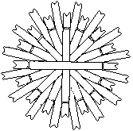
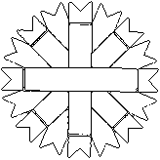
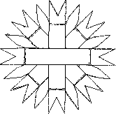
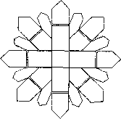
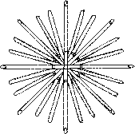
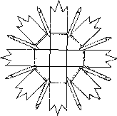
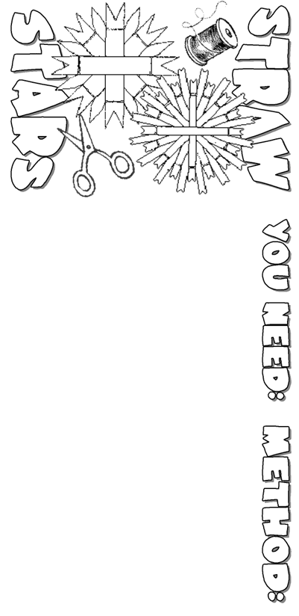 | 8. If you want a simple tied straw star, with the edges in a circle, or clipped into points, it is best to let your bundle of tied straw soak for a short while in a bowl of water, then allow it to dry flat underneath a weight. Once dry, you can trim the edges as you like. Some of the inner ties can be removed, and you can add coloured thread to decorate your star.  9. You can tie the straws at a shorter or a longer length and cut the ends in different way, and see how you can make each star different. These will all look lovely on a Christmas tree, or attached to a gift-wrapped parcel.
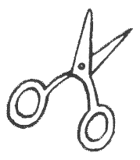  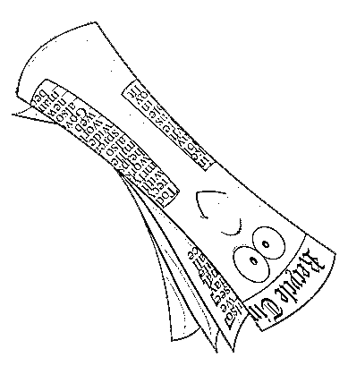  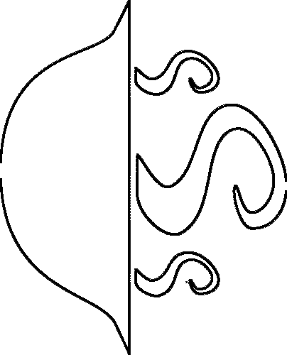  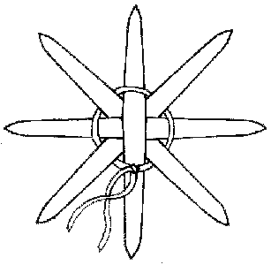  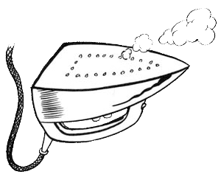  1. Hollow straws  2. Strong thread  3. Sharp scissors  4. Hot water  5. Newspaper  6. Iron | 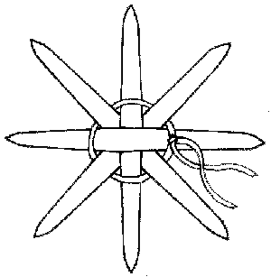  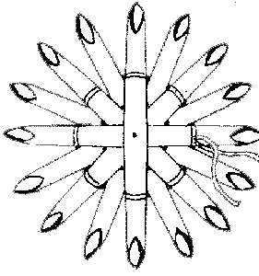  4. Tie four straws together in the centre by weaving your thread over and under the straws  (see picture 1) and securing with a simple knot.  This will give you 8 ends.  5. With four more straws, make up a second  8-end bunch of straws.  6. Place one bunch of tied straws on top of each other. Position them so that you can now join these two bunches together by weaving in and out, as in Step 4. Pull the thread in as closely  to the centre as you can without breaking the straw. This will give you 16 ends. (see picture 2).  7. With another eight straws, repeat the process again to produce a second 16-end bunch of straws. Now place one bunch on top of the other, staggering the straws carefully, and weave in and out as you did before. This will give you 32 ends.  1  2
1. Place the straws in a bowl full of hot water and weigh them down with something to keep them underwater.
2. After half an hour remove the straws from the water and wrap them in a wet towel. This will prevent your straws from drying out while you are working.
3. Iron the damp straw to get flat strips. With ironing on different heat you will get variety of tones from gold to dark brown.

Make Your Mini Book: http://notredamke.rkc.si/english/minibook/MiniBookInstructions.doc

