

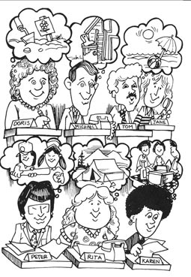

1. Complete the story using going to and the verb in brackets.

It's Friday afternoon, and all the employees at the Acme Insurance Company are thinking about their plans for the weekend.

Doris 1)____________________ (plant) flowers in her yard. Michael 2)_____________________ (paint) his house. Tom and Jane 3)________ _______________ (go) to the beach.

Peter 4)____________________ (play) baseball with his children. Rita 5)___________________ (go) camping in the mountains. Karen and her friends 6)_________________ (have) a picnic.

Unfortunately, the employees at the Acme Insurance Company are going to be very disappointed. According to the radio, it' s going to rain cats and dogs all weekend!
____  / 6

2. Answer the questions.

1. What's Doris going to do this weekend?
______________________________________________________________
2. What's Michael going to do? ______________________________________________________________
3. What are Tom and Jane going to do?
______________________________________________________________
4. What's Peter going to do?
______________________________________________________________
5. What's Rita going to do?
______________________________________________________________
6. What are Karen and her friends going to do?
______________________________________________________________
7. Why are they all going to be disappointed?
______________________________________________________________
8. What are YOU going to do this weekend?
______________________________________________________________
9. What's the weather forecast?
______________________________________________________________

____ / 9

Mi _________ il gelato 1 Mi _________ il gelato 1 Mi _________ il gelato Bottom of Form

