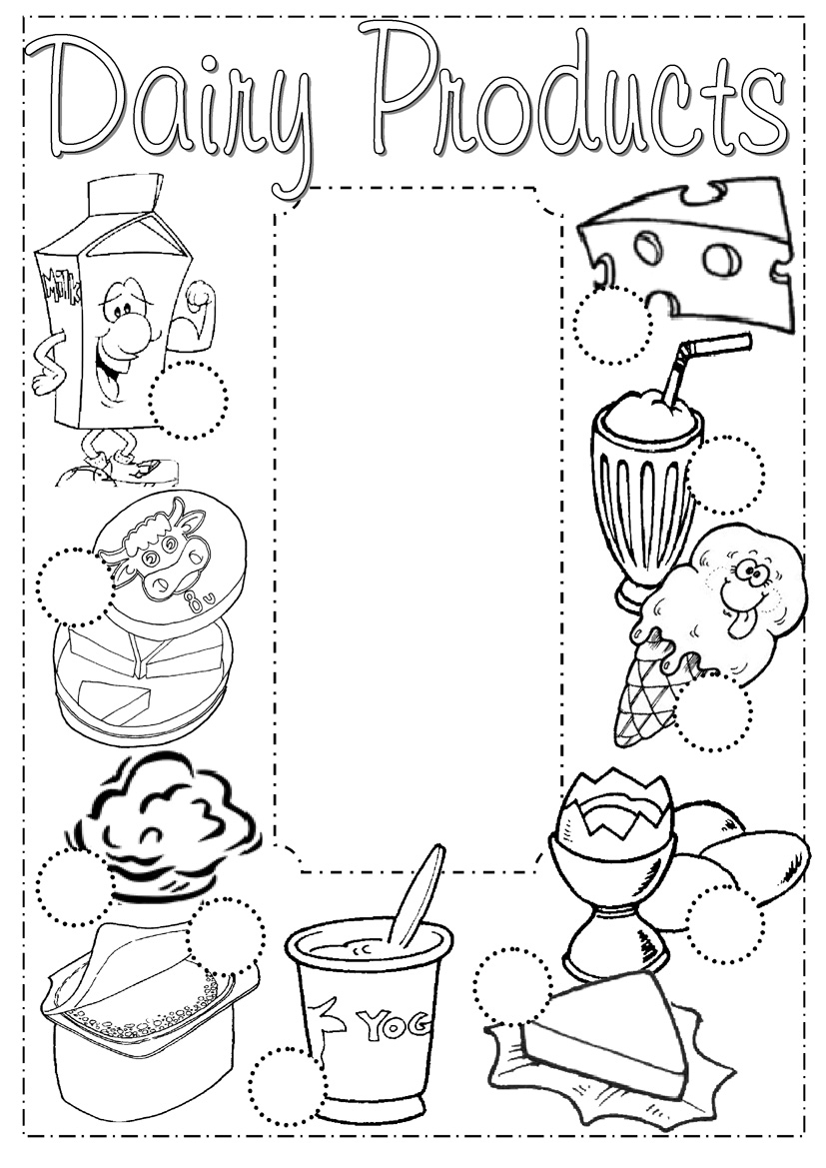
milk
cheese
cottage cheese
yoghurt
eggs
ice cream
melted cheese
milk shake
butter
cream

