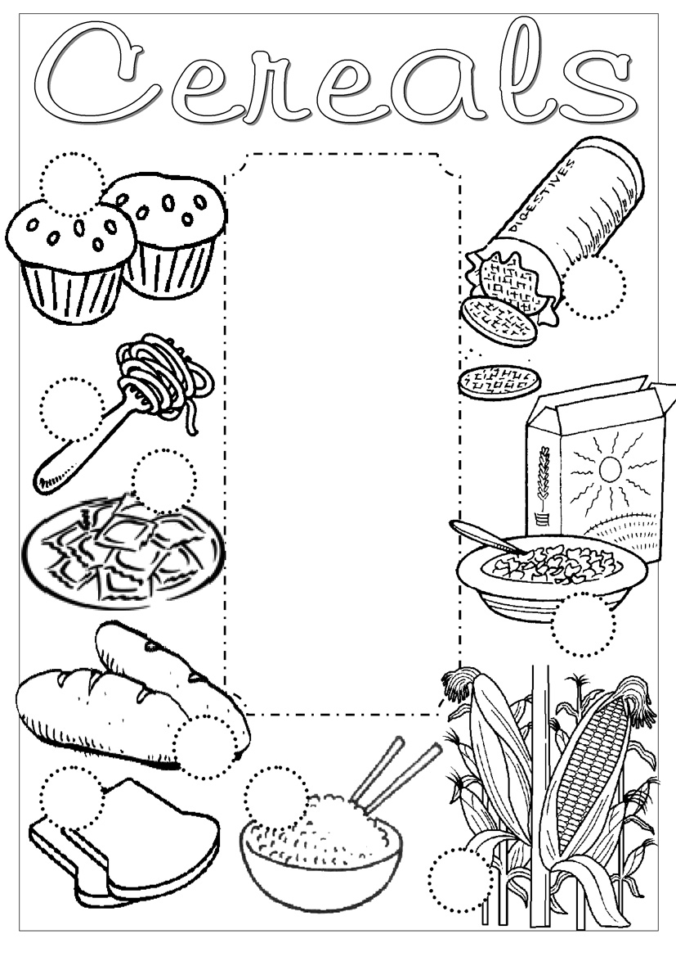
- bread
- biscuits
- cereal
- maize
- muffins
- pasta
- rice
- spaghetti
- toast

