Present Simple or Continuous?

My sisters, my brother, and I are busy this afternoon. We are staying after school, and we are practising different things.

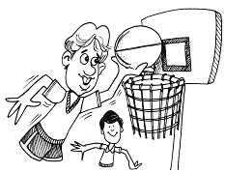

I 1)______________ (practise) basketball this afternoon. I 2)______________ (practise) basketball every day after school. My basketball coach 3)______________ (tell) me I 4)______________ (be) an excellent basketball player, and my friends 5)______________ (tell) me I 6)______________ (play) basketball better than anyone else in the school.
I 7)______________ (want) to be a professional basketball player when I 8)______________ (grow) up. That's why I 9)______________ (practise) every day.

____  / 12
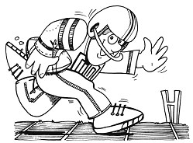

My brother Jimmy 1)______________ (practice) football this afternoon. He 2)______________ (practice) football every day after school. His football coach 3)______________ (tell) him he 4)______________ (be) an excellent football player, and his friends 5)______________ (tell) him he 6)______________ (play) football better than anyone else in the school.
Jimmy 7)______________ (want) to be a professional football player when he 8)______________ (grow) up. That's why he 9)______________ (practice) every day.
____ / 10


My sister Susan 1)______________ (practise) the violin this afternoon. She 2)______________ (practise) the violin every day after school. Her music teacher 3)______________ (tell) her she 4)______________ (be) an excellent violinist, and her friends 5)______________ (tell) her she 6)______________ (play) the violin better than anyone else in the school.
Susan 7)______________ (want) to be a professional violinist when she 8)______________ (grow) up. That's why she 9)______________ (practise) every day.
____ / 10

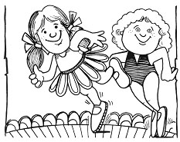

My sisters Patty and Melissa 1)______________ (practise) ballet this afternoon. They 2)______________ (practise) ballet every day after school. Their dance teacher 3)______________ (tell) them they 4)______________ (be) excellent ballet dancers, and their friends 5)______________ (tell) them they 6)______________ (dance) ballet better than anyone else in the school.
Patty and Melissa 7)______________ (want) to be professional ballet dancers when they 8)______________ (grow) up. That's why they 9)______________ (practise) every day.
____ / 10

1. What / Patty and Melissa / do / this afternoon?
2. How often / they / practise?
3. What / their dance teacher / tell / them?
4. What / their friends / tell / them?
5. What / they / want / to be / when / they / grow up?

Mi _________ il gelato 1 Mi _________ il gelato 1 Mi _________ il gelato Bottom of Form

