
Cut and play.
How much time do you need to read all cards correctly?

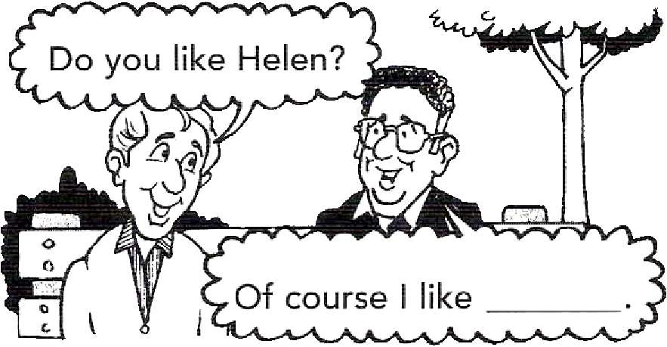
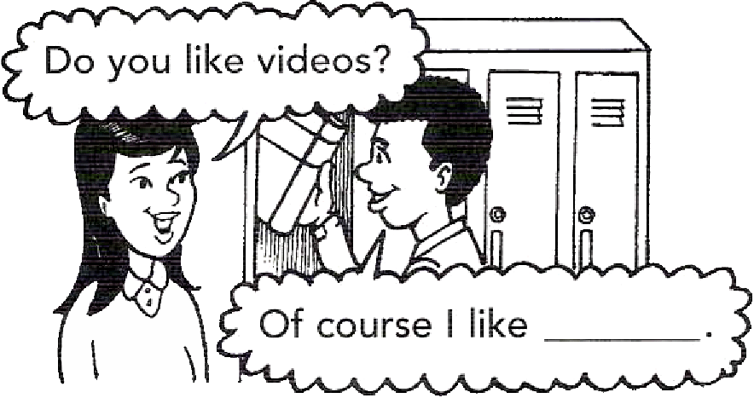
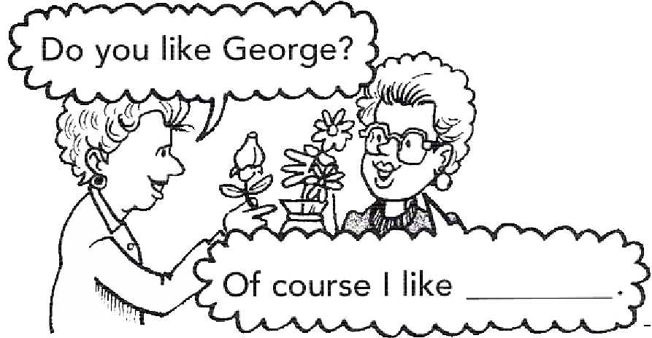
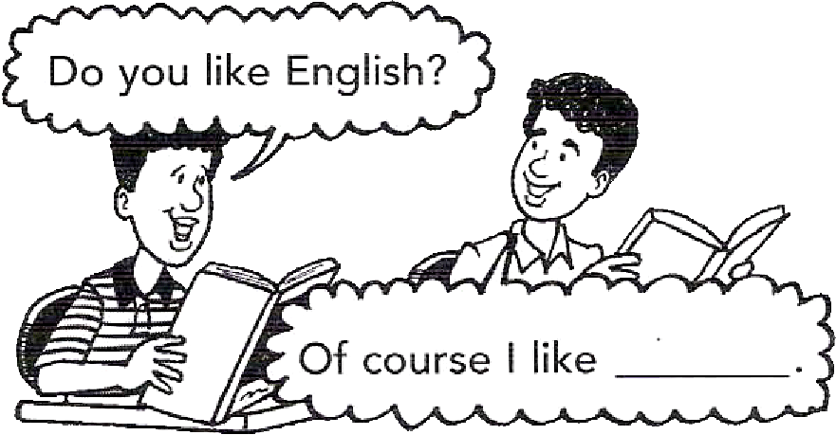
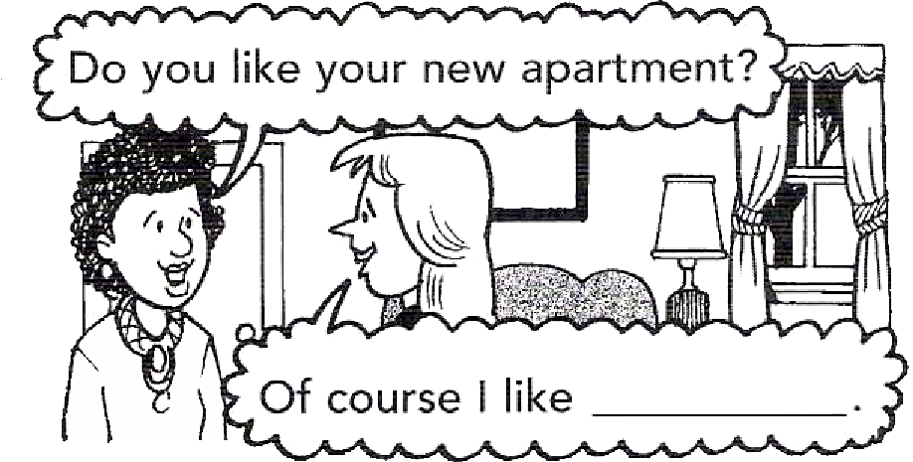
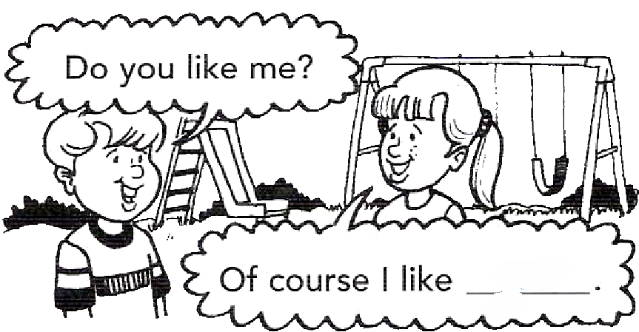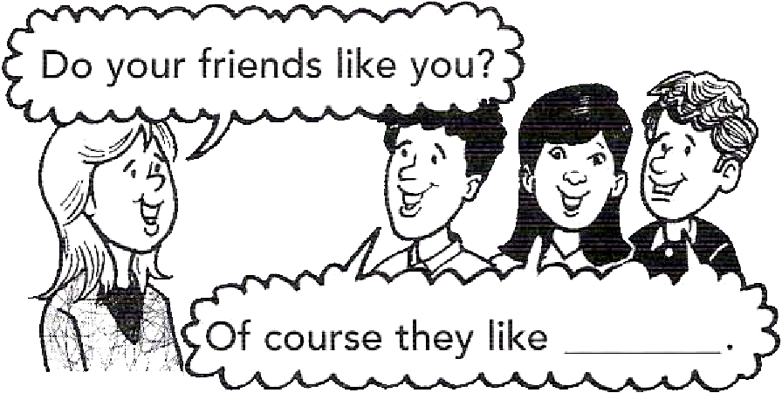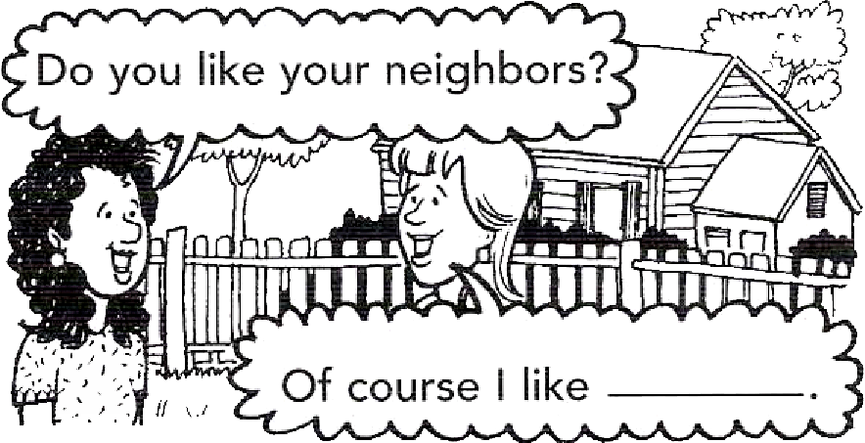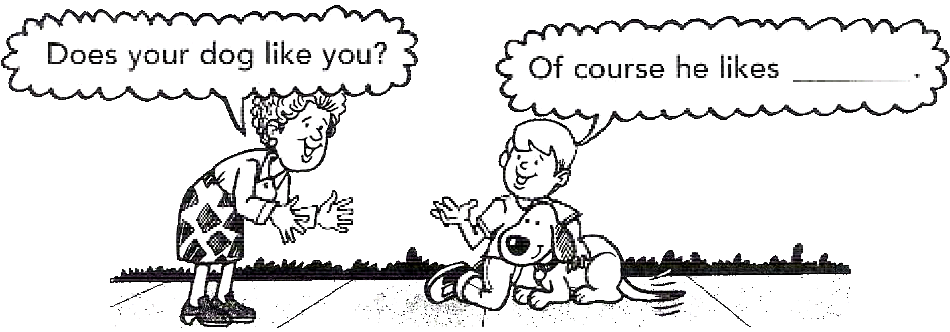
ME
YOU
HIM
HER
US
THEM
IT

ME
YOU
HIM
HER
US
THEM
IT
ME
YOU
HIM
HER
US
THEM
IT
ME
YOU
HIM
HER
US
THEM
IT
ME
YOU
HIM
HER
US
THEM
IT
ME
YOU
HIM
HER
US
THEM
IT
ME
YOU
HIM
HER
US
THEM
IT
ME
YOU
HIM
HER
US
THEM
IT
ME
YOU
HIM
HER
US
THEM
IT
ME
YOU
HIM
HER
US
THEM
IT
ME
YOU
HIM
HER
US
THEM
IT

