
PRESENT SIMPLE / CON.
WH-QUESTIONS
EXERCISE 1
Make the following WH-questions.

1 - They are writing emails.
What ?

2 - Jim’s playing the violin.
What?

3 - My mother is cooking lunch.
What ?

4 - I’m phoning my friend.
Who?

5 - We are going to the park.
Where ?

6 - They are watching a tennis match.
What ?

7 - Sue’s wearing a pink hat.
What?

8 - I’m visiting my uncle.
Who?

EXERCISE 2 Now turn the sentences from Exercise 1 into PRESENT SIMPLE.

1 - They _______________ emails.
What ?

2 – Jim _______________ the violin.
What?

3 - My mother _______________ lunch.
What ?

4 – I _______________ my friend.
Who?

5 - We _______________ to the park.
Where ?

6 - They _______________ a tennis match.
What ?

7 – Sue _______________ a pink hat.
What?

8 – I _______________ my uncle.
Who?
EXERCISE3 Put the verbs in bracket into PRESENT SIMPLE and make the questions.

1 - My friends _______ (go) to school by bus.
Where ?

2 - Mark ___________ (do) her homework.
What?

3 - We ___________ (talk) to Mary.
Who?

4 - Tom ___________ (wash) his hands.
What?

5- They ___________ (learn)French.
What ?

6 – She ___________ (phone) her mother.
Who?

7 - Linda ___________ (sit) in the garden.
Where?

8 - Tom ___________ (watch) a film.
What ______________________________?

EXERCISE 4 Now turn the sentences from Exercise 3 into PRESENT CONTINUOUS.

1 - My friends _______________ home.
Where ?

2 - Mark _______________ her homework.
What?

3 - We _______________ to Mary.
Who?

4 - Tom _______________ his hands.
What?

5 - They _______________ French.
What ?

6 – She _______________ her mother.
Who?

7 - Linda _______________ in the garden.
Where?

8 - Tom _______________ a film.
What ______________________________?

Adapted from Mar: http://www.eslprintables.com/printable.asp?id=191554#thetop

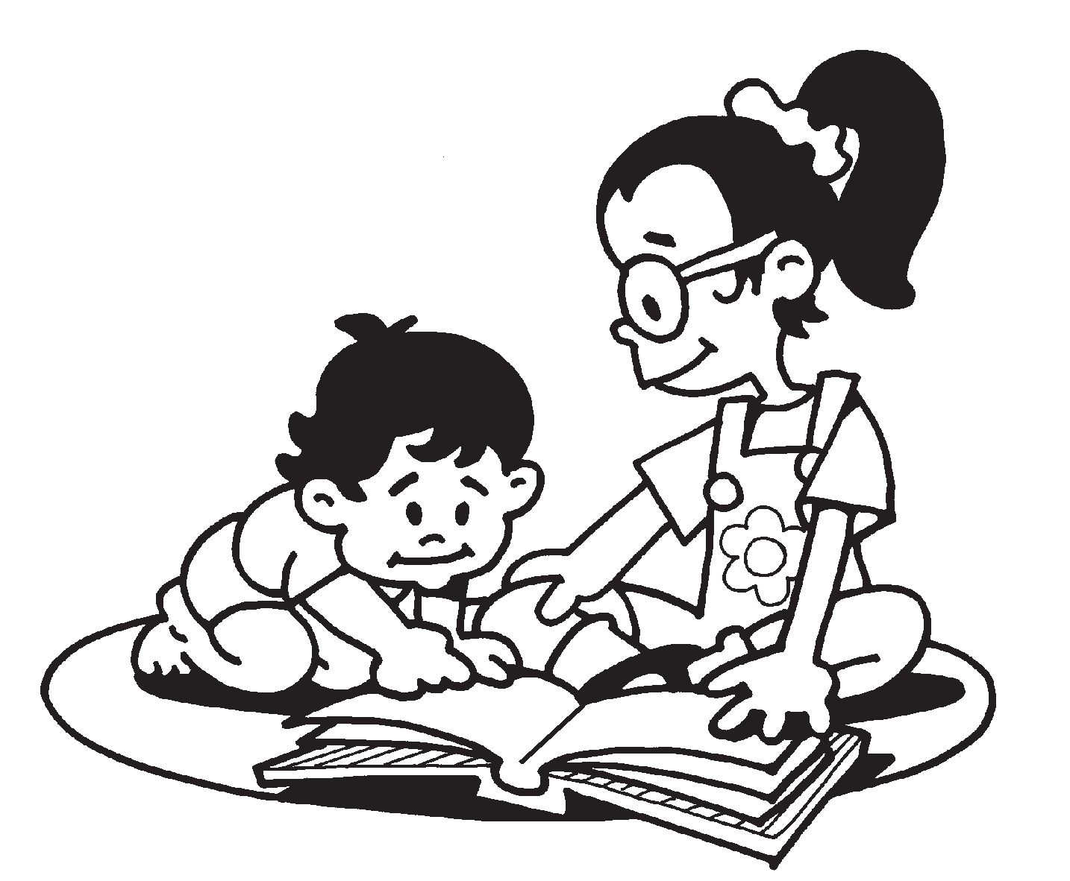
PRESENT SIMPLE SHORT answers

I-Yes, I do. No, I don’t
You-Yes, you do. No, you don’t.
He-Yes, he does. No, he doesn’t.
She-Yes, she does. No, she doesn’t.
It-Yes, it does. No, it doesn’t.
We-Yes, we do. No, we don’t.
You-Yes, you do. No, you don’t.
They-Yes, they do. No, they don’t.

PRESENT CONTINUOUS SHORT answers

I-Yes, I am. No, I’m not.
You-Yes, you are. No, you aren’t.
He-Yes, he is. No, he isn’t.
She-Yes, she is. No, she isn’t
It-Yes, it is. No, it isn’t.
We-Yes, we are. No, we aren’t.
You-Yes, you are. No, you aren’t.
They-Yes, they are. No, they aren’t.

EXERCISE Read the text and answer the questions using SHORT ANSWERS
These are the Brown’s children, Sandy, Lisa and Ben. Sandy is 19
years old. She’s a secretary and works in an office from Monday to
Friday. Today is Sunday so she’s at home, reading a book with her
sister Lisa, 14 and her brother Ben who is 10. They usually have
breakfast together on Sundays, then they go to the park, they have
lunch with their parents and afterwards Sandy reads funny
stories to Lisa and Ben. At 4 o’clock they usually go to Bristol to
visit their grandmother, Cindy. They love Sundays!

SHORT ANSWERS

1 - Does Sandy work as a secretary? ___________ 2 – Does she wear glasses? ______________

3 - Is Ben listening to music? ________________ 4 - Is he listening to Sandy? _____________

5 - Is Sandy working today? __________________ 6 - Are they at the park? _______________

7 - Do they go to the park on Sundays? __________ 8 - Is Lisa sleeping ? __________________

9 - Does Sandy work in a shop? ________________ 10 - Is Lisa reading a book? _____________

11 - Do Lisa and Ben work? ___________________ 12 - Are they singing now? ______________

13 - Are Lisa and Ben at school? _______________ 14 - Are they having fun? _______________

15 - Do they go to school on Sundays? __________ 16 - Do they like Sundays? ______________

17 - Does Cindy live in London? ________________ 18 - Is Ben playing tennis? ______________

19 - Is Lisa watching a film? _________________ 20 - Does Cindy live in Bristol? ___________

21 - Do they enjoy Sundays? _________________ 22 - Is Ben drinking water? _____________
Adapted from Mar: http://www.eslprintables.com/printable.asp?id=192775#thetop

