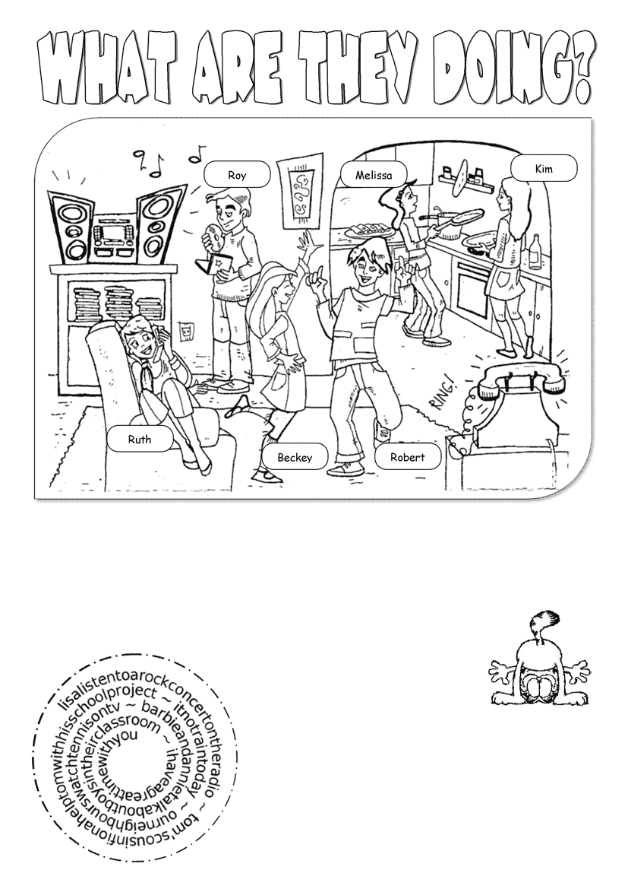

2. Find words in the spiral and write
sentences in the present continuous tense.
Lisa is listening to _____________________________
___________________________________________
___________________________________________
___________________________________________
___________________________________________
___________________________________________

Melissa and Kim _____________________________________________
Ruth _____________________________________________________
Becky and Robert ____________________________________________
Roy ______________________________________________________
The phone _________________________________________________

dance
phone with a friend
Listen to the music
make pancakes
ring

