PROJECT 1
REVISION
Unit 1 and 2

1 Write the numbers.

5 ______________ 18 ______________
70 ______________ 62 ______________ 14 ______________ 90 ______________
31 ______________ 3 ______________
100 ______________ 42 ______________
____ / 10

2 What’s in the pictures.

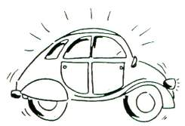

1 __________________________________

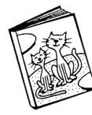

2 __________________________________



3 __________________________________

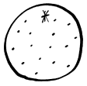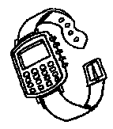

4 __________________________________
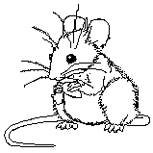

5 __________________________________

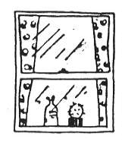

6 __________________________________

____ / 12

3 Where are the things? IN, ON or UNDER?

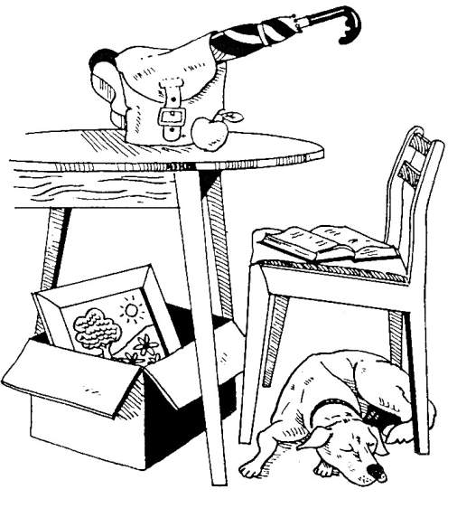

1 The apple is ________________________
2 The dog is _________________________
3 The bag is _________________________
4 The umbrella is _____________________
5 The book is ________________________
6 The picture is _______________________
7 The box is _________________________
____ / 7
4 AM, IS or ARE? Complete the sentences.

- Polly ______ in the garden.
- We ______ friends.
- This letter ______ for you.
- I ______ at school.
- She ______ in the kitchen.
- He ______ on the phone.
- They ______ on holiday.
- Our teacher ______ great!
- This postcard ______ from Tony.
- You _____ at home.
____ / 10

5 Rewrite the sentences in the short form.

1 ______________________________________________
2 ______________________________________________
3 ______________________________________________
4 ______________________________________________
5 ______________________________________________
6 ______________________________________________
7 ______________________________________________
8 ______________________________________________
9 ______________________________________________
10 ______________________________________________
____ / 10

6 Complete the speech bubbles.

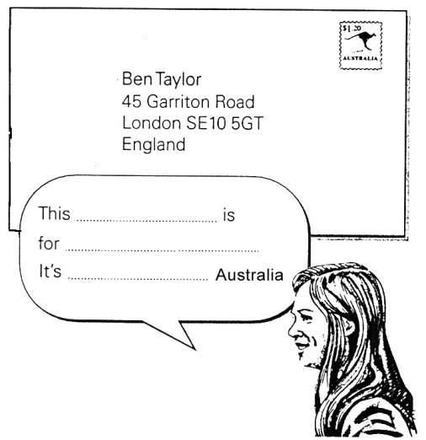
____ / 3
7 Read the conversation and complete the postcard.

Ben Here’s the postcard.
Mrs Taylor Who’s it for?
Ben It’s for Mandy and me.
Mrs Taylor Who’s it from?
Ben It’s from Tony and Jane. They’re on holiday.
Mrs Taylor Oh, where are they?
Ben They’re in New York

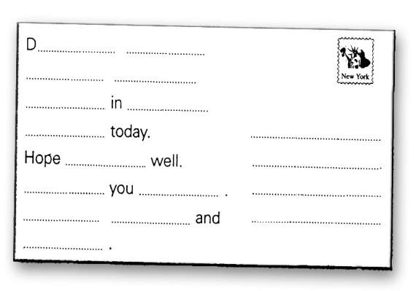
____ / 14

8 HIS HE’S or HER?

1 Where’s your dad? _____ in the garden.
2 This present is for Mandy.
It’s ______ birthday.
3 What’s this boy’s name?
_____ name is Ben.
4 Is Ben from Britain? Yes, ______ from London.
5 This present is for my brother.
It’s ______ birthday. _____ fifteen today.
6 Here is Greg with _____ friends.
7 What’s this woman’s name?
_____ name’s Mrs Taylor.
8 Is this Mandy’s bag?
No, _____ bag is on the chair.
9 This is Jack Mason. ______ from New York.
____ / 10

