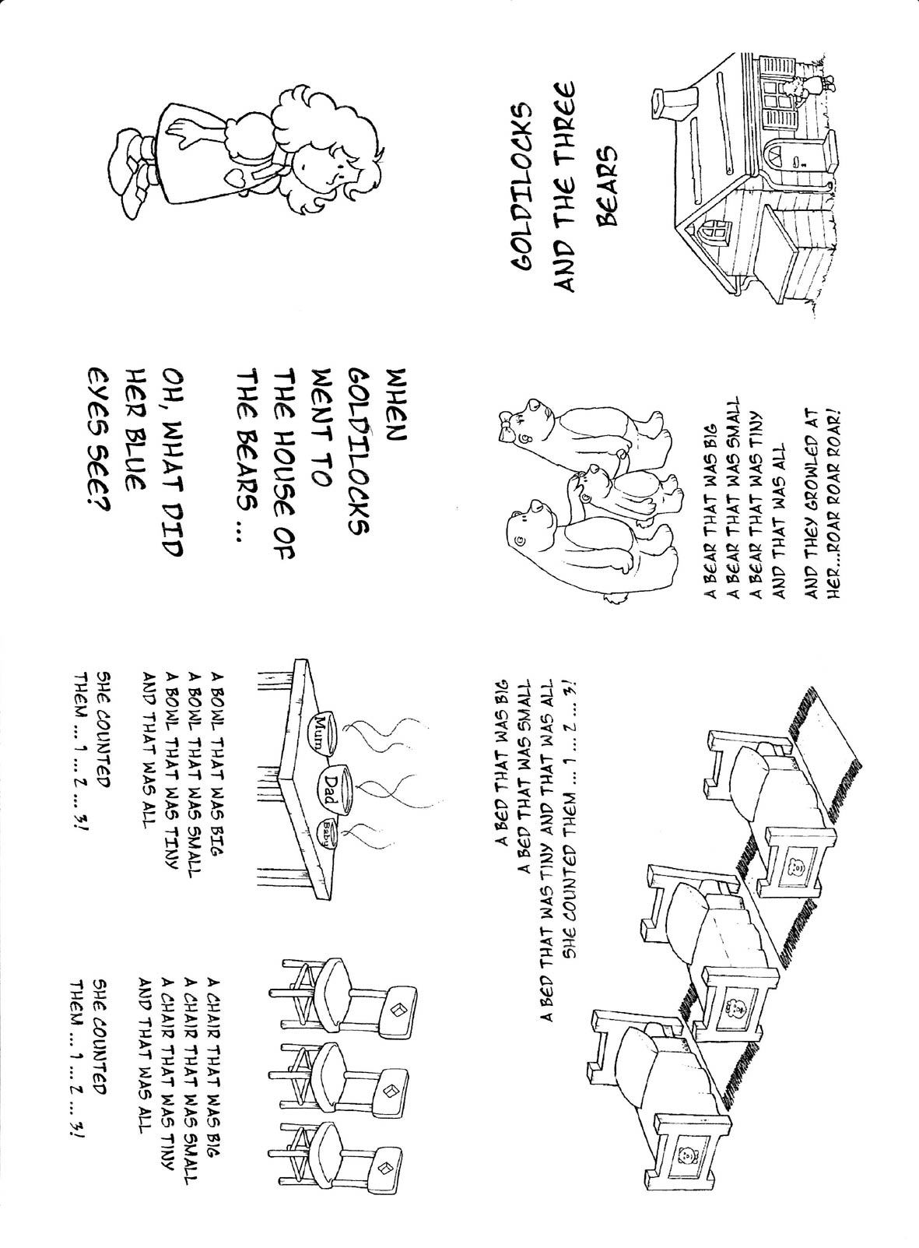

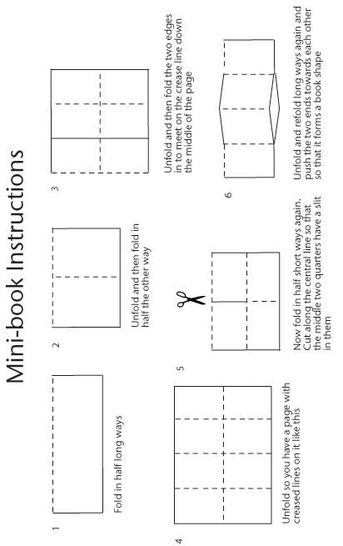
When Goldilocks went to the house of the bears

C F
When Goldilocks went to the house of the bears
C G
Oh, what did her blue eyes see?
F G
A bowl that was big
C a
A bowl that was small
F C a
A bowl that was tiny and that was all
C a G C
She counted them…1…2…3!

When Goldilocks went to the house of the bears
Oh, what did her blue eyes see?
A chair that was big
A chair that was small
A chair that was tiny and that was all
She counted them…1…2…3!

When Goldilocks went to the house of the bears
Oh, what did her blue eyes see?
A bed that was big
A bed that was small
A bed that was tiny and that was all
She counted them…1…2…3!

When Goldilocks went to the house of the bears
Oh, what did her blue eyes see?
A bear that was big
A bear that was small
A bear that was tiny and that was all
And they growled at her…ROAR ROAR ROAR!

You can watch and listen to this song on:
http://www.britishcouncil.org/kids-songs-goldilocks.htm

