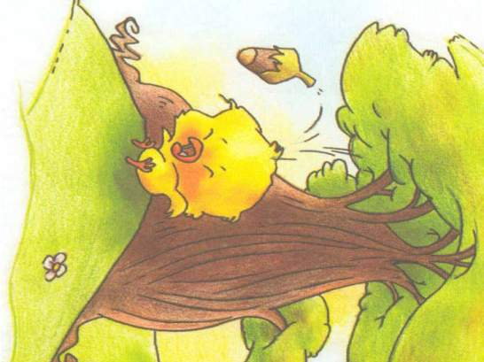
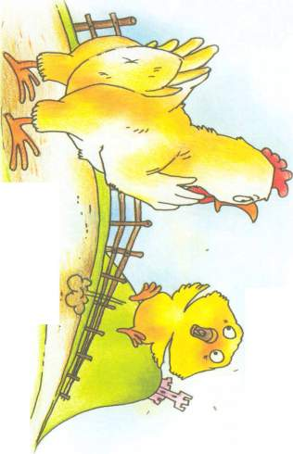
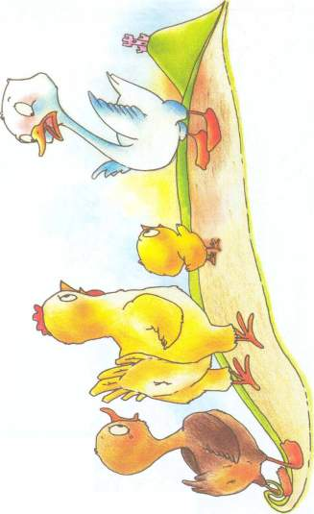
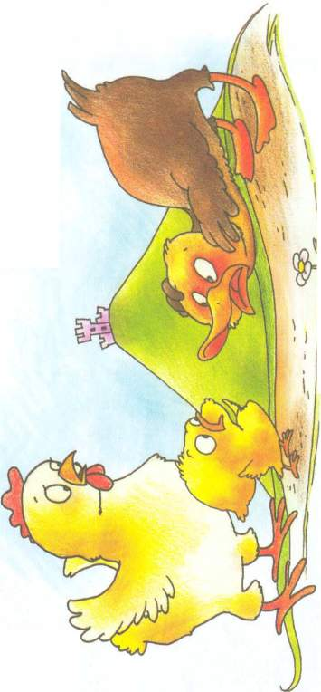
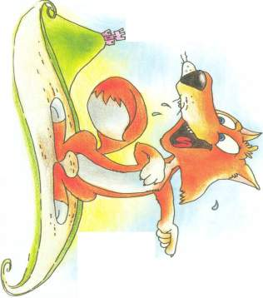

Make Your Mini Book: http://notredamke.rkc.si/english/minibook/MiniBookInstructions.doc
Adapted from Beo Beo, September 2006

Chicken
Licken
live
be
fall
say
see
go
see
be
say
go
see
say
be
live
know
(not) take
be
But Foxy Loxy ________ them to the king. Foxy ______ them to his house and that _____ the end of Chicken Licken, Henny Penny, Ducky Lucky and Goosey Loosey …

On the way they _____ a goose. "Hello, my name is
Chicken Licken," _____ Chicken Licken.
"Hello, my name _____ Goosey Loosey," said
the goose. "Where are you going?"
"The sky is falling down.
I must tell the king!"
_____ Chicken Licken.
"The sky? I will
come with you,"
_____ Goosey Loosey.
And off they _____
to find the king.

Finally they ____ a fox.
"Hello, my name _____ Chicken Licken," _____ Chicken Licken.
"Hello, my name _____ Foxy Loxy," _____ the fox. "Where are you going?"
"The sky is falling down. I must tell the King!" _____ Chicken Licken.
"The king? I _____ where the king ______. Follow me!" ______ Foxy Loxy.

On the way they ______ a duck. "Hello, my name _____ Chicken Licken," _____ Chicken Licken.
"Hello, my name ____ Ducky Lucky," _____ the duck. "Where are you going?"
"The sky is falling down. I must tell the king!" _____ Chicken Licken.
"The sky? I will come with you," _____ Ducky Lucky.
And off they _____ to find the king.

Read and complete the story with the suitable verbs in the present or past simple.

Once upon a time there _______ Chicken Licken. One day as he was resting under a tree, a nut _______ on his head. "Ouch!" _______ Chicken Licken. "The sky is falling down! I must tell the king!"
On the way he _______ a hen.
"Hello, my name _____ Chicken Licken," he _______.
"Hello, my name _______ Henny
Penny," _______ the hen.
"Where are you going?"
"The sky is falling down.
I must tell the king!"
_______ Chicken Licken.
"The sky? I will come with you,"
_______ Henny Penny.
And off they _______
to find the king.

