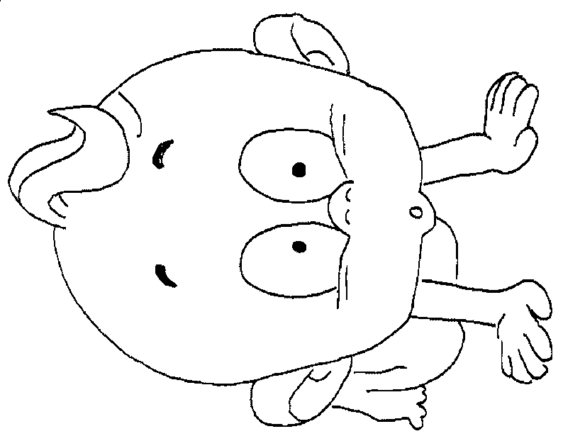
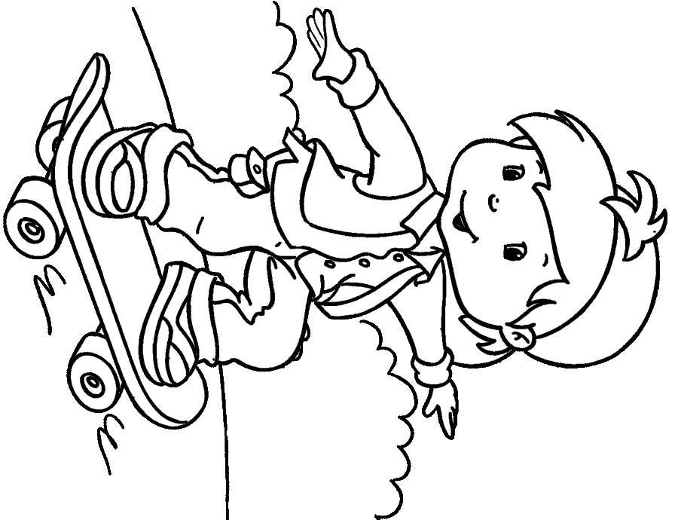
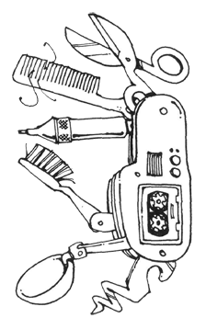
Answer the questions:

Can you drive a space ship?
......................................................
Can you ride a horse?
......................................................
Can you play the trumpet?
......................................................
Can your dad cook?
......................................................
Can your grandma swim?
......................................................
Can your teacher skate?
......................................................Can your friends sing?
......................................................
I
We
You
They
He
She
It

can
can’t

swim.
dance.
speak English.

+
-

Can

I
we
you
they
he
she
it

swim.
dance.
speak English.

?
Can you speak French?
Can he play the violin?
Yes, I can.
No, I can't.
Form questions and answer them:

(he/play the guitar – yes)
Can he play the guitar? – Yes, he can.

(we/speak Italian – no)
...............................................................
(you/ride a bike – yes)
................................................................
(he/eat three hot dogs in a minute – no)
................................................................
(they/run very fast – yes)
................................................................
(you/walk on your hands – no)
................................................................
(it/drive a car – no)
................................................................
(she/play chess – yes)
................................................................
(they/dance – no)
.....................................................................

WHAT this little baby can't do?
______________________________________________________________________

__________________________________________________

He can’t rollerblade.

__________________________________________________

__________________________________________________

______________________________________________________________________

CAN YOU ...?
WHAT CAN YOU DO WITH THIS PENKNIFE?
You can cut your nails.
__________________________________________________
__________________________________________________

__________________________________________________

__________________________________________________

__________________________________________________

Make Your Mini Book: http://www.eslprintables.com/printable.asp?id=123271#thetop

