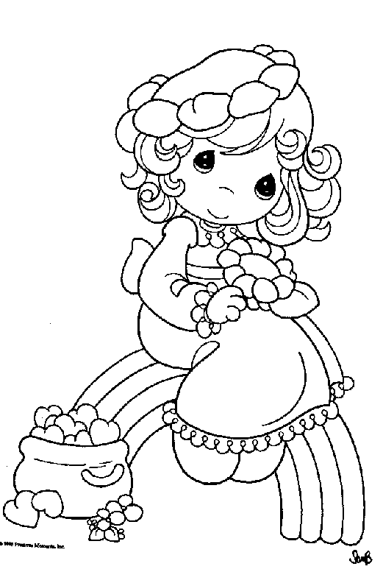

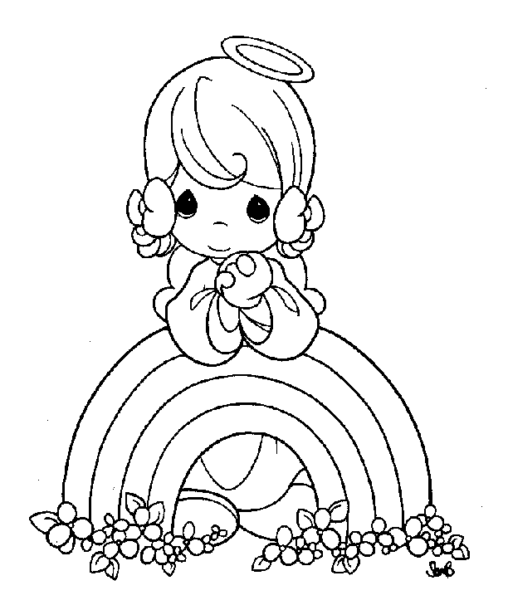
9
10
7
1
2
COLOURS
3
5
4
6
8

R

E

U

O

N

I

1
2
3
4
5
6
7
8
9
10

