

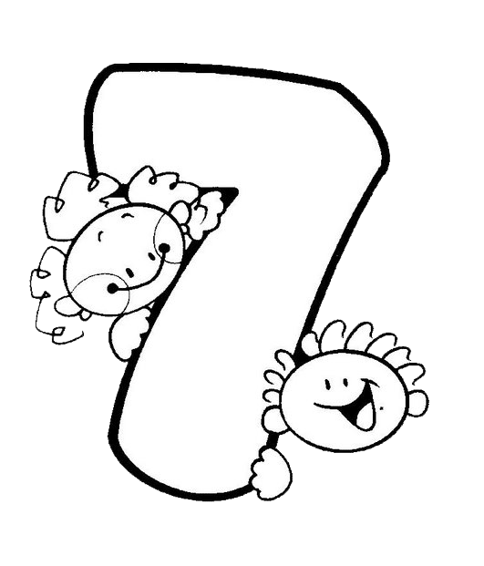
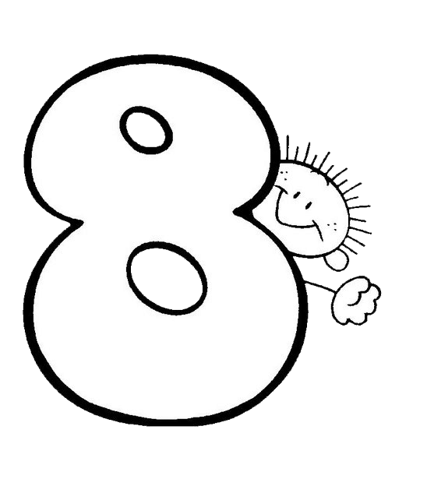
NUMBERS
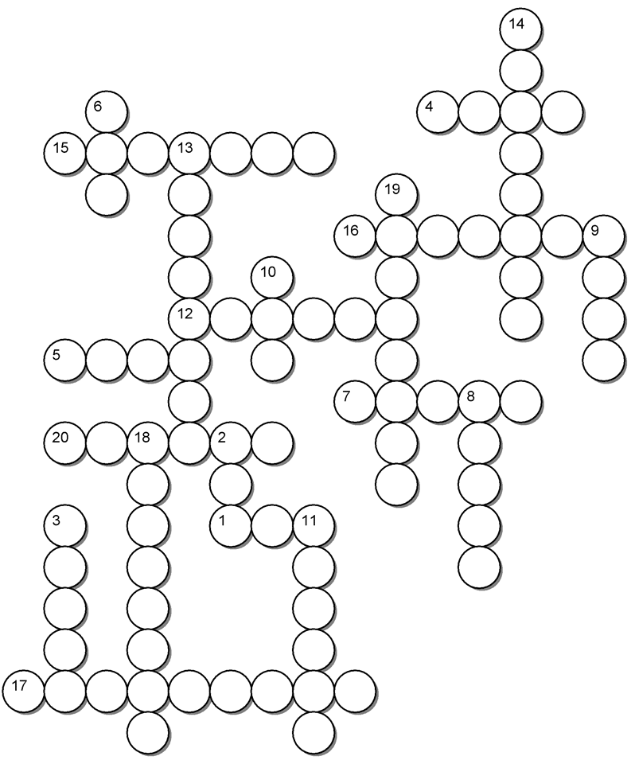
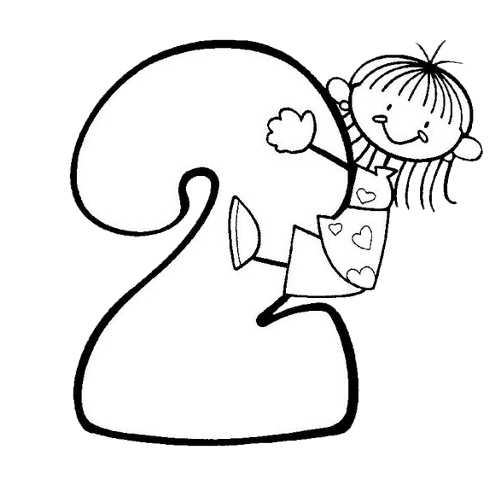
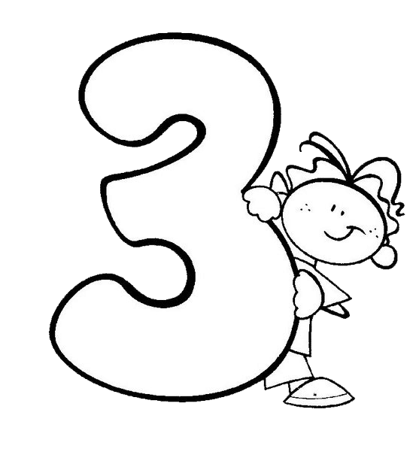
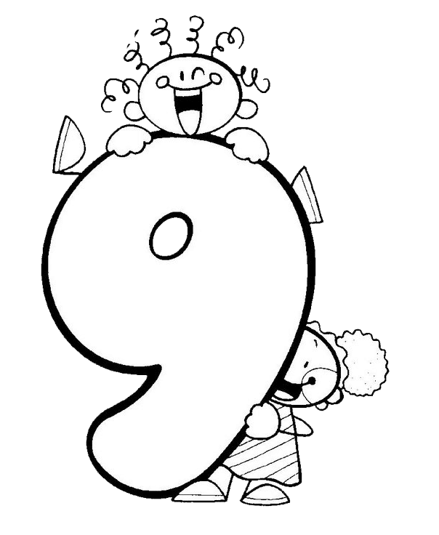
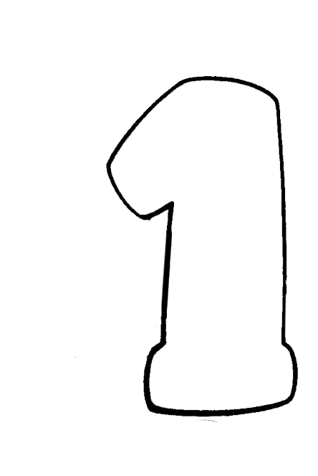
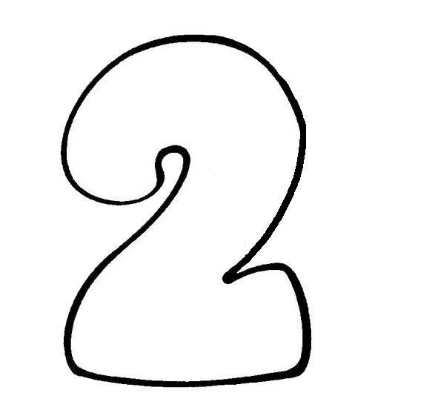
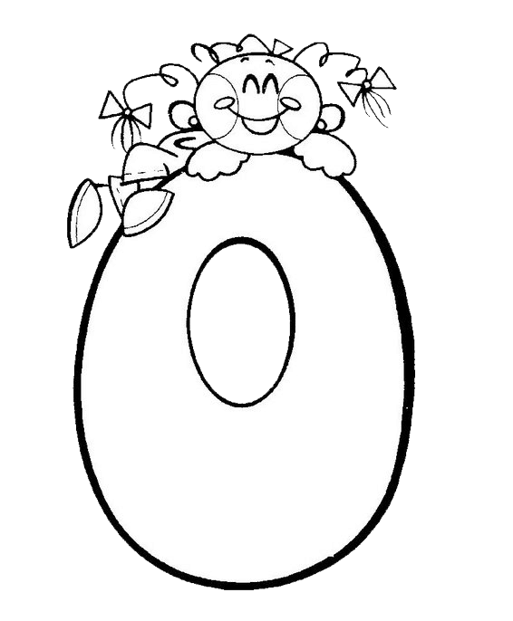








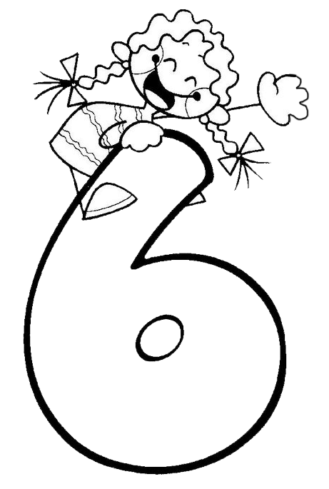



17
11
8
12
20
4
15
18
2
1
10
19
5
3
16
9
13
6
14
7
EIGHT
EIGHTEEN
ELEVEN
FIVE
FIFTEEN
FOUR
FOURTEEN
NINE
NINETEEN
ONE
SEVEN
SEVENTEEN
SIX
SIXTEEN
TEN
THIRTEEN
THREE
TWELVE
TWENTY
TWO

NUMBERS
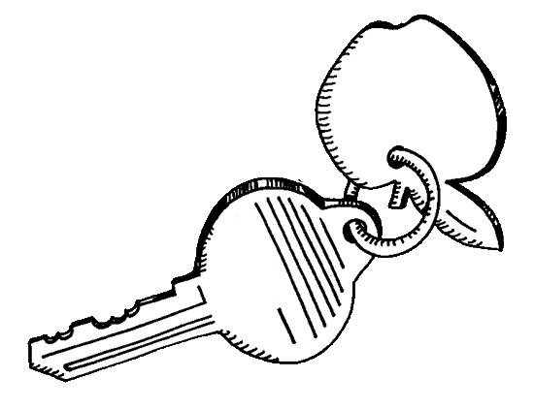
14
6
4
15
13
19
16
9
10
12
5
7
8
20
18
2
3
1
11
17
EclipseCrossword.com
S
F
F
T
T
H
R
E
E
S
I
X
I
W
V
F
V
E
I
G
H
T
E
E
N
T
H
I
R
T
E
E
N
N
E
W
T
W
O
T
E
T
E
N
Y
N
E
N
L
E
L
E
V
E
N
S
V
S
N
N
I
N
E
T
E
E
N
F
X
V
O
T
E
I
G
H
T
F
O
U
R
T
E
E
N
N
R
E
N
I
N
E

