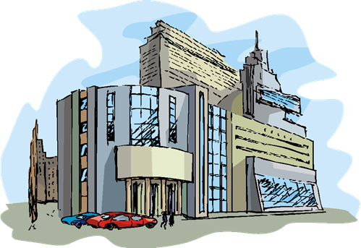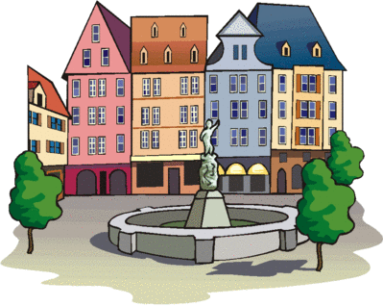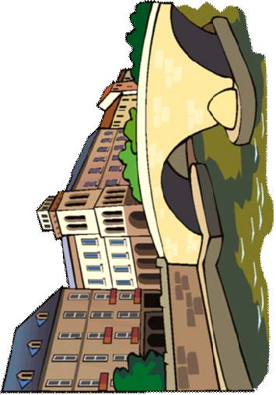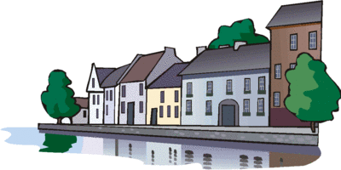
PARLIAMENT
CONCERT HALL
Church
TOWN HALL
LIBRARY
GYM
POST
BAR
SHOE
BUTCHER
fountain
square
MUSEUM
LIBRARY
Clothes
POST
bridge
river
BANK
SCHOOL
ART
GALERY
Community
river

