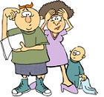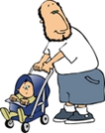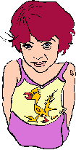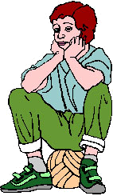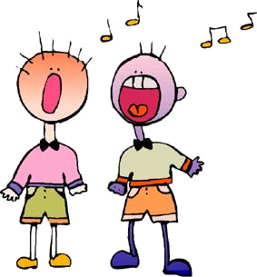
___________?
In my family there are only three people.
__________?
Yes, I have got
a dog.
___________?
My mother
is a secretary.
___________?
My father is
a babysitter.
___________?
I look just like my brother Tim.
___________
your new girlfriend?
She is very shy and reserved.
_____________?
My teacher is slim and not very tall. She has got short brown hair.
___________?
Today I am very bored.
___________
your little brother?
He is two years old.
___________?
My favourite subjects at school are Music, History and English.
___________?
Yes, I exercise regularly.
___________
any ambitions?
Yes. I’d like to go to the music school and become a singer.

?
?
?
Personal Questions
?
?
?
Personal Questions
?
?
?
Personal Questions
?
?
?
Personal Questions
?
?
?
Personal Questions
?
?
?
Personal Questions
?
?
?
Personal Questions
?
?
?
Personal Questions
?
?
?
Personal Questions
?
?
?
Personal Questions
?
?
?
Personal Questions
?
?
?
Personal Questions

