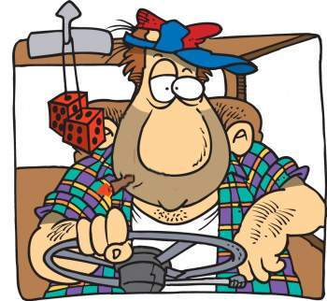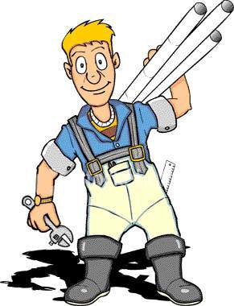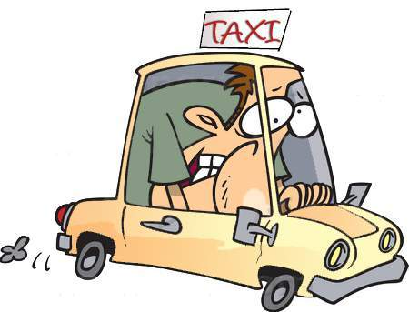
WORK
outdoors
alone
often overtime

place
WEAR
casual clothes
a cap
jeans
clothes
USE
papers
tool bag
mobile phone
tools
TRAVEL a lot
TRANSPORT large amounts of goods
LOAD and UNLOAD things
HAVE to be fit

Lorry Driver
DRIVE
a lorry

vehicle
WORK
outdoors
in a city

place
usually
NOT WEAR
a uniform
clothes
USE
a city map
mobile phone
tools
HAVE to BE expert in driving
PICK up people and bring them to their destination
TAKE the quickest and safest rout
KNOW the city very well
Taxi Driver
DRIVE
a taxi car

vehicle
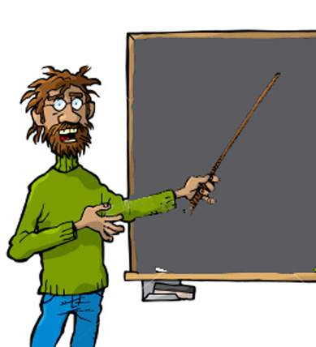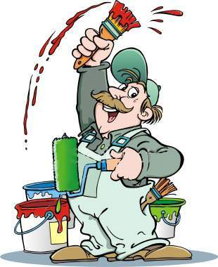
WORK
in a school
place
usually
NOT WEAR
special clothes for work

clothes
USE
a board
books
a red pen

tools

Work with children or young people
TEACH people reading, writing and many other things
Teacher
NOT DRIVE
at work

vehicle
WORK
inside and outside
people’s house
place
WEAR
overalls
a cap
clothes
USE
paintbrushes and a paint

tools
paint and DECORATE flats, houses and public buildings
GET dirty at work
Work hard

House Painter
DRIVE
a car or a van

vehicle
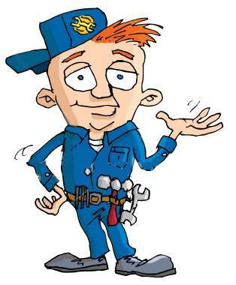
WORK
inside and outside houses and public buildings

place
WEAR
overalls
a cap

clothes
USE
spanners
hammers
screwdriver
other tools
tools

MAKE and REPAIR things
DO various small tasks

Handyman
DRIVE
a car or a van

vehicle
WORK
inside and outside houses and public buildings

place
WEAR
overalls
clothes
USE
tubes
an adjustable spanner
tools

REPAIR or CONNECT water pipes and things like toilets and baths
Plumber
DRIVE
a car or a van

vehicle
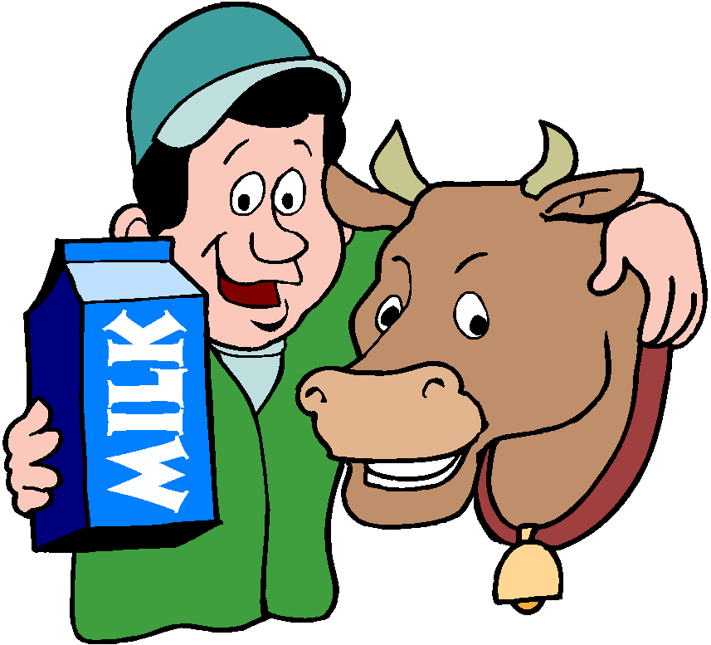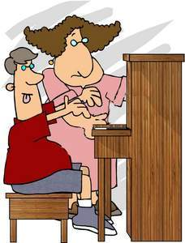
WORK
on a farm
place
WEAR
overalls
a hat
clothes
USE
forks
rakes
machines
tools
get into buildings illegally
STEAL things
Farmer
DRIVE
a tractor

vehicle
WORK
in a music school
place
NOT WEAR
special clothes for work

clothes
USE
music paper
a music desk
musical instruments
tools

TEACH the musical instruments
Music Teacher
NOT DRIVE
at work
vehicle
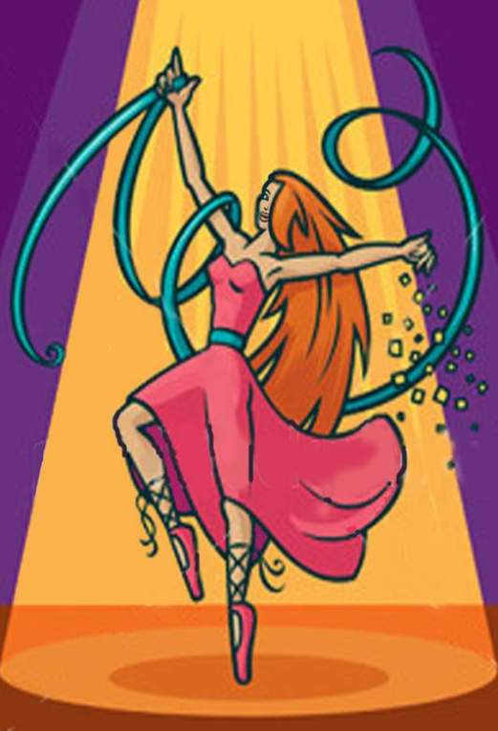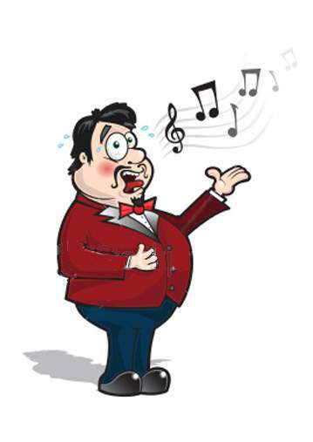
WORK
in ballet
musical shows
opera
television
movies
music videos
commercials
place
WEAR
a dance costume
ballet slippers or dance shoes
clothes
USE
colorful strips
illuminated dance floor

tools
EXPRESS ideas, rhythm and sound with his/her body
often work as a group
CAN teach in a dance class

Dancer
NOT DRIVE
at work

vehicle
WORK
indoors and outdoors
in operas and theatres
television and radio studios
place
WEAR
costumes
make up

clothes
USE
a microphone
a musical instrument
recording equipment
tools
HAVE a hard job
STUDY and MEMORIZE music and words
PERFORM in public

Singer
NOT DRIVE
at work
vehicle
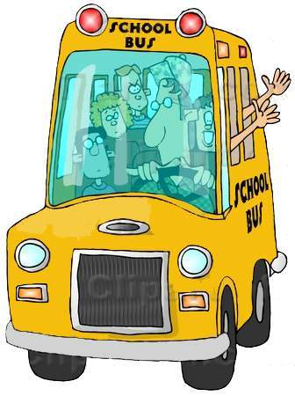
WORK
for the bus transport service
place
WEAR
a uniform
a hat

clothes
USE
a seat belt
tools
CARRY children from home to school
HAVE a responsible job

Schoolbus Driver
DRIVE
a long vehicle with many seats

vehicle

