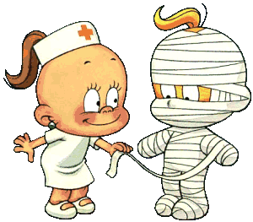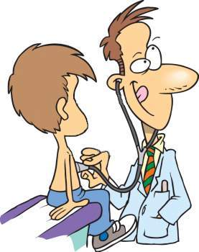
WORK
in a hospital or in a health centre
place
WEAR
a white uniform
a small white hat

clothes
USE
bandages
a thermometer
a computer
tools
HELP a doctor
GIVE injections to the patients
MEASURE pressure and fever
care for sick people in the hospital

Nurse
DRIVE
an ambulance car

vehicle
WORK
in a hospital or
in a health centre
place
WEAR
a white uniform and sometimes gloves
clothes
USE
a stethoscope and other medical instruments

tools
TREAT sick or hurt people
PRESCRIBE medicine
OPERATE

Doctor
DRIVE
an ambulance car

vehicle

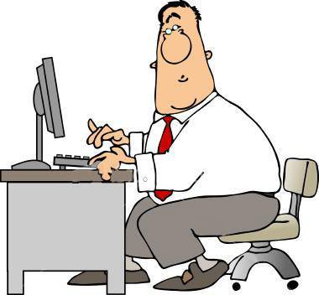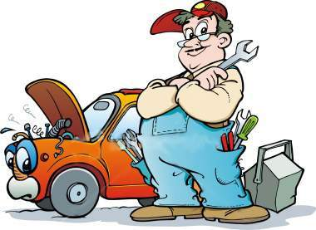
WORK
in the office
place
WEAR
smart clothes
a tie

clothes
USE
a computer
tools

Write letters
ANSWER the phone
Office Worker
NOT DRIVE
at work

vehicle
WORK
in a workshop

place
WEAR
overalls
a cap
clothes
USE
a spanner
a screwdriver

tools

MEND cars in the garage
Mechanic

DRIVE
an official car

vehicle
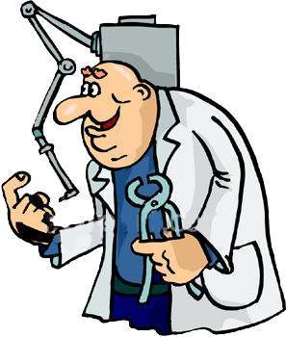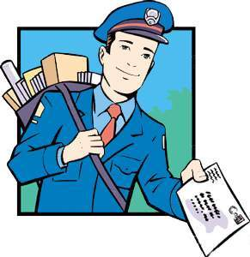
WORK
in a dental clinic
or in a health centre
place
WEAR
a white uniform
gloves

clothes
USE
tongs and burrs
tweezers
other dental instruments
tools

TREAT people’s teeth
Dentist
not DRIVE
at work

vehicle
WORK
for the post office

place
WEAR
a uniform
a postman’s hat
clothes
USE
a postman’s bag
tools

BRING cards and letters
to every house and flat
dogs usually don’t like him.
Postman
DRIVE
a postman’s van,
a motorbike or
a bike

vehicle
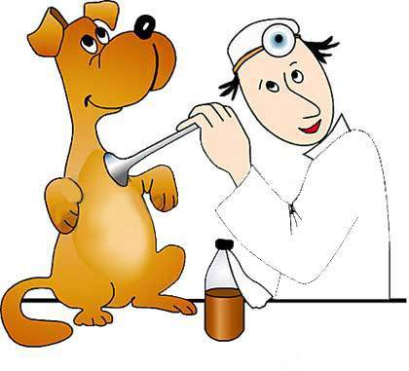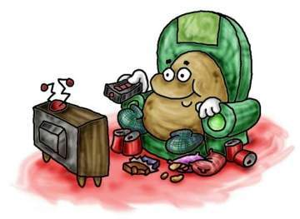
WORK
in the
veterinarian
surgery
place
WEAR
a white uniform

clothes
USE
a stethoscope
and other veterinarian instruments
tools

CARE for sick and hurt animals

Vet
DRIVE
an ambulance car

vehicle
WORK
at home

place
WEAR
casual clothes
clothes
USE
a remote control
tools

SPEND much time sitting or lying down in front of television
Eat a lot of chips and DO nothing
Couch Potato

TRAVEL
by car
vehicle
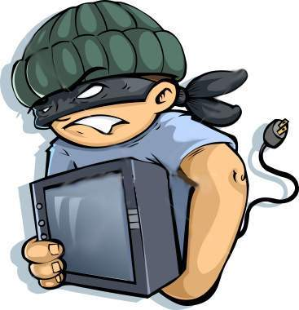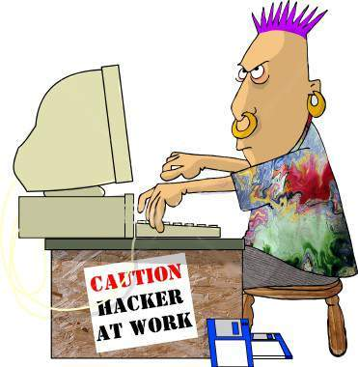
WORK
at other
people’s home

place
WEAR
casual clothes
a disguise
gloves
a hut
wig (sometimes)
clothes
USE
a picklock
a gun
tools
get into buildings illegally
STEAL things
Burgler
DRIVE
a car

vehicle
WORK
indoors
usually at home
place
WEAR
casual clothes
earrings in his ear and nose

clothes
USE
a computer
tools
Illegally get into computer system
of other people
Computer Hacker
NOT DRIVE
at work
vehicle

